

# Nokia 8210

## Type of device: Mobile

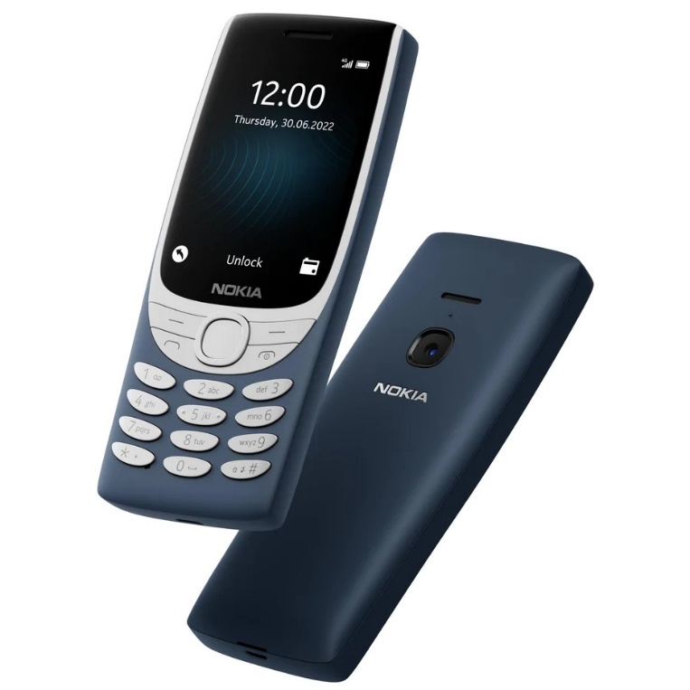

Actual Display Size : 2.8 inches

Button Type : Physical Keypad

Network Capability : 3G,4G

Year of Release : 2022

Average Price : $114 as of 23 11 2022

Other : Unisoc T107

## Accessibility Features:

### Cognitive

* GPS
* Photo Telephone List
* Simple Reminders

Voice Notes

### Hearing Impairment and Deaf

* Bluetooth or Wi-Fi
* Text Messaging/SMS
* Vibrating Alerts - Adjustable

Visual Alerts - Incoming Calls

### Vision

* Battery Alert - Audible
* Bluetooth or Wi-Fi
* Brightness Adjustable
* Key Marker – Raised '5'
* Key Numbers - Standard Layout
* Key Press - Vibration or Click

Personalised Shortcuts

### Speech

* Bluetooth or Wi-Fi
* Messaging Options - IM
* Messaging Options - MMS
* Predictive Text

SMS Personalisation and Reuse

### Physical

* Automatic Answer
* Automatic Redial
* Bluetooth or Wi-Fi
* Guarded/Recessed Keys
* Headset - plug connected
* Physical Dialling Keys
* Predictive Text
* Speaker-phone option

Visible Focus Indicators

## How and where to get it from?

You can buy this phone from [JB Hi-Fi](https://www.jbhifi.com.au/search?page=1&query=nokia%208210&saleItems=false&toggle%5BonPromotion%5D=false), [Big W](https://www.bigw.com.au/search?text=nokia+8210), [Nokia](https://au.mobileshop.nokia.com/a/feature-phones/nokia/nokia-8210-4g/100000155?variant_id=311&gclid=Cj0KCQiA4OybBhCzARIsAIcfn9m8N97BfShJcPwVO52l835JCkdmnPdOngQV_4_TRZgkonkKQ60PGFcaAvgsEALw_wcB&gclsrc=aw.ds), [Officeworks](https://www.officeworks.com.au/shop/officeworks/search?istCompanyId=0403b0ba-0671-498f-aeb7-e2ff71b61924&istFeedId=00ff5695-1f12-4ff3-82f4-49dd39a43a69&istItemId=rwpaqpttm&istBid=t&cm_mmc=Google:SEM:Always_on:RP|Technology|Mobile%20Phones|General||||SH|Smart|&s_kwcid=AL!12073!3!599903478911!!!u!1732274156297!&gclid=Cj0KCQiA4OybBhCzARIsAIcfn9kDUuBy8Ak3MWCaQzGKS-Bg_fe-mr3PRGFIFbtXAt-2IEeJV0-CxMsaAo9IEALw_wcB&gclsrc=aw.ds&q=nokia%208210&view=grid&page=1&sortBy=bestmatch), and other retailers.

## More information is available on:

[Nokia 8210 4G webpage](https://au.mobileshop.nokia.com/a/feature-phones/nokia/nokia-8210-4g/100000155?variant_id=311&gclid=Cj0KCQiA4OybBhCzARIsAIcfn9m8N97BfShJcPwVO52l835JCkdmnPdOngQV_4_TRZgkonkKQ60PGFcaAvgsEALw_wcB&gclsrc=aw.ds)

[Nokia 8210 4G PDF User Guide webpage](https://www.nokia.com/phones/en_gb/support/api/pdf/libra-user-guide)